Why was the Weimar Republic weakened by the depression?
The Weimar Republic was weakened for several reasons.
- It lacked a strong leader to reduce the worst effects of the depression. Stresemann, who might have provided such strong leadership, died just a few weeks before the Wall St Crash.
- The Weimar constitution had encouraged weak and short lived coalitions, unable to provide solutions to major problems, and the depression highlighted these weaknesses.
- The two leading parties in the coalition government, the Centre Party and the Social Democrat Party (SDP) fell out with each other. Hermann Muller, the leader of the SDP, refused to agree cuts in unemployment benefit, favoured by Heinrich Bruning, the leader of the Centre Party. Muller resigned, leaving Bruning as Chancellor, but without a majority in the Reichstag. Bruning asked President Hindenburg to use Article 48 of the constitution which meant, in an emergency such as the depression, laws could be issued without having to go through the Reichstag.
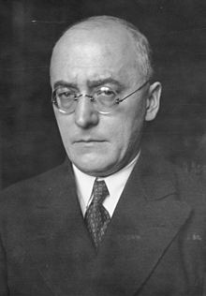
Heinrich Bruning
- From 1930, Germany effectively ceased to be a democracy, as the Reichstag met less and less frequently, and it was seen as ineffective by many Germans. Moreover, the German government was now controlled by an 84 year old President, an ex-army leader, who seemed well past his prime.
- To make matters worse, Bruning’s government introduced unpopular economic policies to try to deal with the depression. They remembered the hyperinflation of 1923 and refused to increase government spending or print more money. Instead, the Chancellor raised taxes, which infuriated businessmen already suffering from the depression, reduced wages and made cuts in unemployment benefit.
- Many Germanys now turned to support the more extreme parties, such as the communists and the Nazis, who seemed to offer possible solutions to the depression. The communists blamed the capitalist system and insisted that only a communist government could get Germany out of the depression. The Nazis, on the other hand gave scapegoats for Germany’s economic problems – the Jews, the Weimar politicians and the communists.
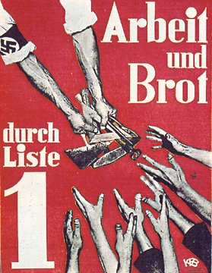

Why was the Weimar Republic weakened by the depression?
The Weimar Republic was weakened for several reasons.
- It lacked a strong leader to reduce the worst effects of the depression. Stresemann, who might have provided such strong leadership, died just a few weeks before the Wall St Crash.
- The Weimar constitution had encouraged weak and short lived coalitions, unable to provide solutions to major problems, and the depression highlighted these weaknesses.
- The two leading parties in the coalition government, the Centre Party and the Social Democrat Party (SDP) fell out with each other. Hermann Muller, the leader of the SDP, refused to agree cuts in unemployment benefit, favoured by Heinrich Bruning, the leader of the Centre Party. Muller resigned, leaving Bruning as Chancellor, but without a majority in the Reichstag. Bruning asked President Hindenburg to use Article 48 of the constitution which meant, in an emergency such as the depression, laws could be issued without having to go through the Reichstag.
Heinrich Bruning
- From 1930, Germany effectively ceased to be a democracy, as the Reichstag met less and less frequently, and it was seen as ineffective by many Germans. Moreover, the German government was now controlled by an 84 year old President, an ex-army leader, who seemed well past his prime.
- To make matters worse, Bruning’s government introduced unpopular economic policies to try to deal with the depression. They remembered the hyperinflation of 1923 and refused to increase government spending or print more money. Instead, the Chancellor raised taxes, which infuriated businessmen already suffering from the depression, reduced wages and made cuts in unemployment benefit.
- Many Germanys now turned to support the more extreme parties, such as the communists and the Nazis, who seemed to offer possible solutions to the depression. The communists blamed the capitalist system and insisted that only a communist government could get Germany out of the depression. The Nazis, on the other hand gave scapegoats for Germany’s economic problems – the Jews, the Weimar politicians and the communists.

