Early problems of the Weimar Republic

The abdication of the Kaiser meant that the Second Reich was over and a new democratic Germany had to be created in the German town of Weimar because the major cities were far too dangerous at the end of the war. This new democratic government, known as the Weimar government, faced immediate and serious threats to its existence from a number of problems:
- Economic crisis and food shortages
- Threats from left-wing extremist groups
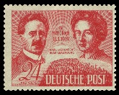
- Threats from right-wing extremist groups
- The nature of the Weimar constitution
Threats from left-wing extremist groups
The Spartacists
These were a group of communists led by Karl Liebknecht and Rosa Luxemburg. They took their name from the Roman slave Spartacus who, 2000 years earlier had led a slave revolt. The Spartacists were unhappy that the Second Reich was going to be replaced, they claimed, by another government controlled by rich people. With so many Germans starving they wanted a government which ruled on behalf of the poor, and which took away the wealth of the rich people.
In 1917 the Bolsheviks had taken control of Russia. They had shown that a small group of communists could overthrow a government in a revolution. In January 1919 the Spartacists staged a revolution in Berlin. After two weeks the revolution was defeated, crushed by the Freikorps. These were armed groups of ex-soldiers. The Weimar government decided to use them to put down the revolt. The did so with great brutality. Many communists, including Liebknecht and Luxemburg were murdered after they were captured.

Munich 1919
In April 1919 another group of communists managed to seize control of the government of Bavaria, the second biggest state in Germany. Again the German government used the Freikorps to put them down.

Threats from right-wing extremist groups
The revolts by left-wing groups had been overcome relatively easily. The right-wing extremists posed a much greater threat because member of the army as well as those who had ruled Germany during the Second Reich supported them. This meant the right-wing extremists were likely to receive mild sentences if they were prosecuted while the left were dealt with much more severely.
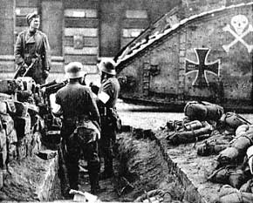
The Kapp Putsch
The Freikorps not only hated communism, they also hated the humiliation of the Treaty of Versailles and the new German government, the ‘November Criminals’, who had signed it. In March 1920, a group of Freikorps, led by Dr Wolfgang Kapp, attempted to take power in Berlin. The Freikorps were also angry because the government had ordered all Freikorps units to disband. The army refused to stop Kapp and his 5000 followers. However, the workers of Berlin did not support the Freikorps and went on strike. Kapp and the Freikorps found they could not govern Berlin and so the revolt collapsed.

The Munich Putsch
Between 1921 and 1923 there were many attempts by extreme groups to seize control of various German cities. They all failed. The most famous example happened in November 1923 when a little known political group, the National Socialist German Workers Party (the Nazis for short), led by Adolf Hitler attempted to seize power. As with all other revolts at this time, it failed.

